INTERNSHIP REPORT

Student Name: Indrajith CV
Register Number: PNAYSCS020
Programme: Full Stack Development
College: PRAJYOTI NIKETAN COLLEGE, PUDUKAD
Internship Organization: ZIUKE Infotech
Internship Title: Full Stack Development Internship
Project Title: Internship Application Website
Total Hours Completed: 60 Hrs
Industry Supervisor(s): Sruthi Sunil , Faculty

Acknowledgment

I express my sincere gratitude to my supervisors for their valuable guidance, continuous support, and constructive feedback throughout the Full Stack Development Internship. Their expertise and encouragement played a vital role in the successful completion of this internship.
I would like to extend my heartfelt thanks to the host organization, ZIUKE Infotech, for providing me with the opportunity to undergo this internship. The structured training program, hands-on project exposure, and professional environment greatly enhanced my technical knowledge and practical skills.
I also thank the team members at ZIUKE Infotech for their cooperation and support during the internship period. Finally, I acknowledge everyone who directly or indirectly contributed to the successful completion of this internship.

Executive Summary

This report presents a comprehensive overview of the Full Stack Development Internship undertaken at ZIUKE Infotech, with a primary focus on the development of an Internship Application Website. The internship aimed to provide practical exposure to modern web development technologies and real-world software development practices.
The project involved designing a responsive user interface, implementing backend logic, creating database structures, and integrating various modules to manage internship postings and student applications. Tools and technologies such as HTML, CSS, databases, and development frameworks were utilized.
The internship experience enhanced technical proficiency, problem-solving skills, and professional understanding, effectively bridging the gap between academic learning and industry requirements.

Internship Certificate
(Scanned copy of the internship completion certificate issued by ZIUKE Infotech is attached here.)

Table of Contents

1. Organization Profile…………………………………………..6
2. Internship Overview…………………………………………. 6
3. Internship Experience…………………………………………7
4. Learning Reflection…………………………………………...8
5. Conclusion…………………………………………………….9

Chapter 1: Organization Profile
1.1 Overview of ZIUKE Infotech
ZIUKE Infotech is a technology-driven organization that provides IT solutions, professional training, and internship programs in various domains including full stack development, web technologies, and software engineering. The organization focuses on equipping students with industry-relevant skills through practical learning.
1.2 Vision, Mission, and Objectives
The vision of ZIUKE Infotech is to create skilled professionals who meet current industry standards. Its mission is to deliver quality technical training combined with real-time project exposure.
1.3 Services and Technology Domains
ZIUKE Infotech offers services in web development, application development, software solutions, and IT training programs.
1.4 Organizational Structure
The organization follows a structured hierarchy including project managers, developers, trainers, and interns, ensuring smooth coordination and learning support.
1.5 Role of the Organization in Skill Development
ZIUKE Infotech plays a key role in enhancing technical and professional skills by offering hands-on training and mentorship.

Chapter 2: Internship Overview
2.1 Internship Duration and Schedule
The internship was conducted for a duration of [mention duration] with regular training sessions and project-based learning.
2.2 Objectives of the Internship
- To gain practical knowledge in full stack development
- To understand real-world web application development
- To develop an Internship Application Website
2.3 Internship Domain: Full Stack Development
The internship covered both frontend and backend development, enabling complete understanding of web application workflows.
2.4 Tools, Technologies, and Platforms Used
- HTML, CSS, JavaScript
- Backend technologies
- Database management systems
- Development tools and IDEs
2.5 Project Overview: Internship Application Website
The project focuses on building a web-based system to manage internship postings and student applications efficiently.

Chapter 3: Internship Experience
3.1 Requirement Analysis and System Planning
Requirements were gathered to understand user roles, system features, and data flow for the application.

3.2 Frontend Design and Development
User-friendly and responsive interfaces were designed using modern web technologies to ensure accessibility.
3.3 Backend Development and Database Design
Backend logic was implemented to handle authentication, application processing, and database operations.
3.4 Implementation of Internship Application Modules
Modules such as registration, login, internship listings, application submission, and tracking were implemented.
3.5 Challenges Faced and Solutions
Challenges included debugging errors and managing data flow, which were resolved through guidance and testing.
3.6 Key Contributions and Achievements
The successful development of a functional Internship Application Website was a major achievement.

Chapter 4: Learning Reflection
4.1 Skills Acquired During the Internship
- Web development skills
- Database design
- Problem-solving
- Team collaboration
4.2 Comparison of Academic Learning and Practical Experience
The internship emphasized practical application beyond theoretical concepts.
4.3 Role of Industry and Internal Supervisors
Supervisors provided valuable technical guidance and professional support.
4.4 Professional and Personal Development
The internship enhanced confidence, communication skills, and career readiness.

Chapter 5: Conclusion
The Full Stack Development Internship at ZIUKE Infotech was a valuable learning experience. The development of the Internship Application Website provided real-world exposure and strengthened technical and professional skills, preparing for future career opportunities.

Appendices

6.1 Internship Photographs with Timestamp
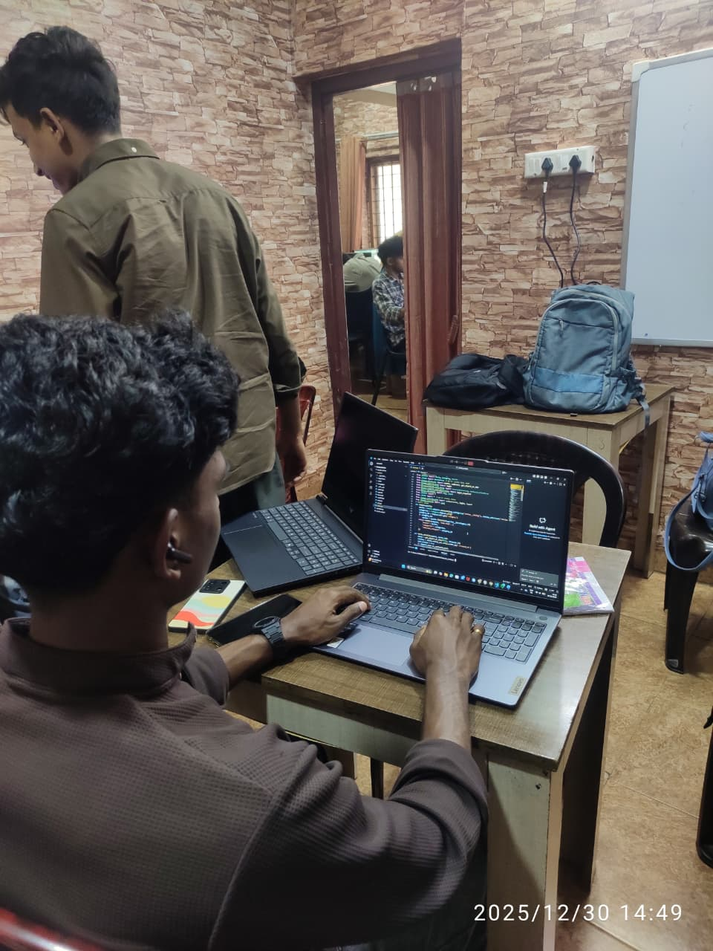

6.2 Workbook / Daily Activity Summary
Click here

